Limit Your Jurisdiction

- Know how your court has jurisdiction (diversity or federal question)
- Select a Jurisdiction before you get started
- If you limit the jurisdiction to Michigan, you will get a lot of state law
- Michigan is in the Sixth Circuit
- Alternatively, select the “Cases” tab under the global search bar to see more jurisdiction options.
- Select “Michigan” as your jurisdiction
- Limit your search as appropriate (i.e., “All Michigan Federal Cases”)
- Enter in your search terms
  - Don’t be afraid to use terms and connectors or other limiters
  - Try a simple search: “standard of review” /15 “summary judgment”
- Apply filers as appropriate!

Know Your Flags

Finding Negative Treatment

- A KeyCite symbol should accompany each case.
- This image shows a case that was overruled: McConnell v. Fed. Election Com'n, 540 U.S. 93, 97; 124 S. Ct. 619, 629; 157 L. Ed. 2d 491 (2003).
- Researchers can quickly view filings, negative treatment, and citing references.
- Red flags will allow you to quickly locate overriding case law.

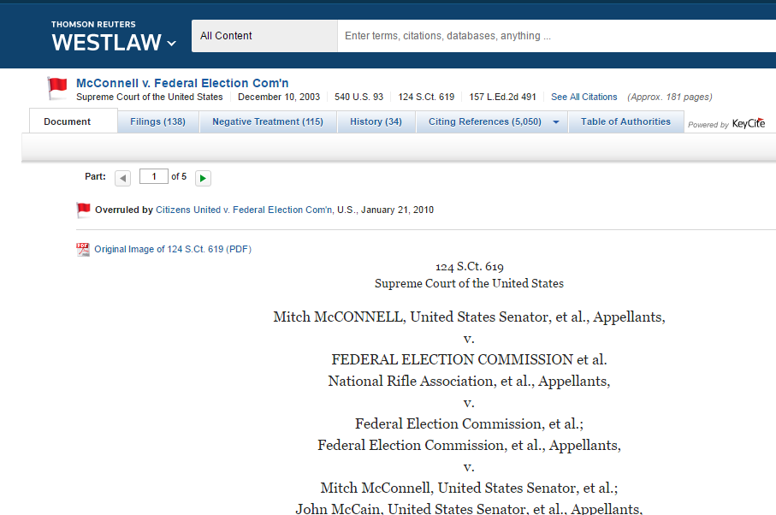

- Select the Negative Treatment Tab
- Check for any direct negative history
- Check for types of treatment
- Look for the “Most Negative” designation
- Review for the type of source providing negative treatment (i.e., case, statute, brief, etc.)
- NOTE—Headnotes on the right side are to the cited case (i.e., McConnell)

KeyCite for Research

- Use the “Citing References” tab to locate additional sources, including cases.
- Find additional potential sources in the right column

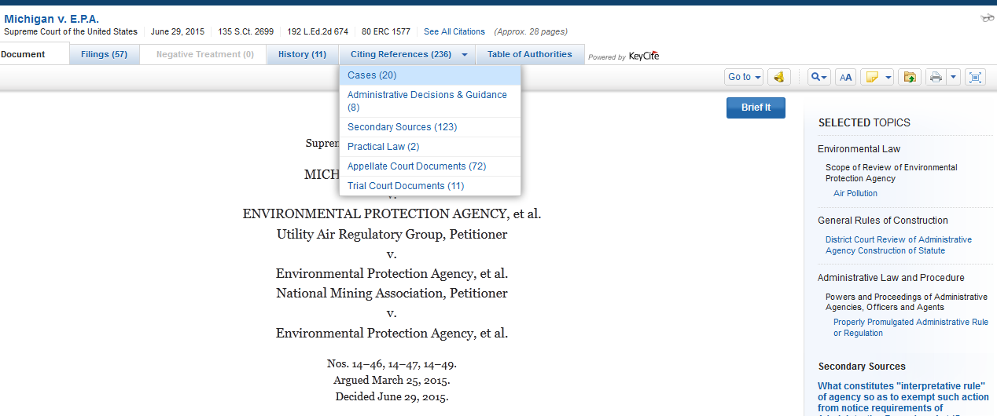

- Check to see the level of treatment
- Check to see the depth of the coverage

Don’t Forget to Utilize Filters to Narrow your Search!

